* CIDR dengan UMLDiagram

  Description automatically generatedDiagram

  Description automatically generatedDiagram

  Description automatically generatedDiagram

  Description automatically generatedDiagram

  Description automatically generatedDiagram

  Description automatically generated

REVISI-----------------------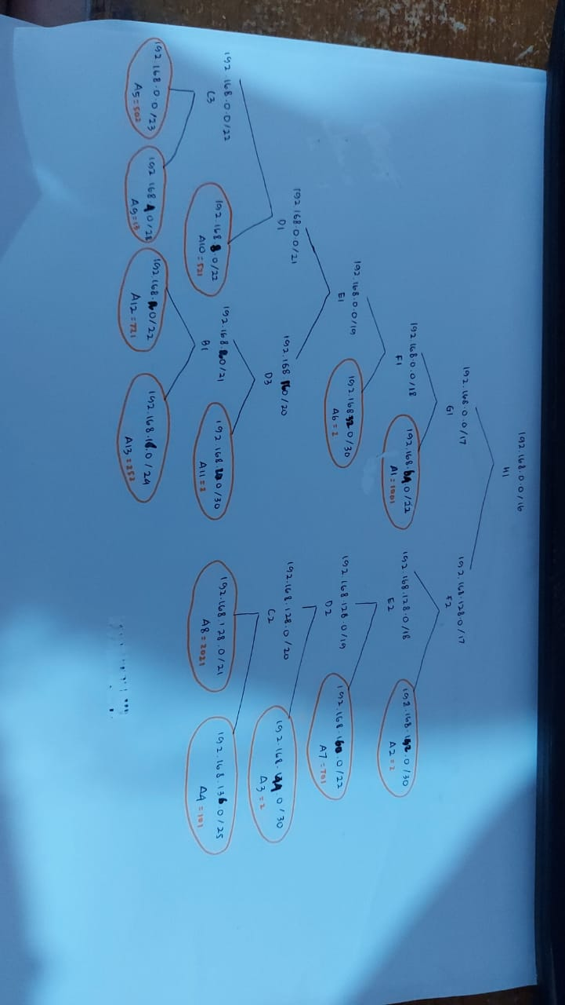

|  |  |  |
| --- | --- | --- |
| subnet | jumlah IP | netmask |
| A1 | 1001 | /22 |
| A2 | 2 | /30 |
| A3 | 2 | /30 |
| A4 | 101 | /25 |
| A5 | 502 | /23 |
| A6 | 2 | /30 |
| A7 | 701 | /22 |
| A8 | 2021 | /21 |
| A9 | 13 | /28 |
| A10 | 521 | /22 |
| A11 | 2 | /30 |
| A12 | 721 | /22 |
| A13 | 252 | /24 |
|  |  |  |
|  |  |  |
| A1 | network ID | 192.168.64.0 |
| netmask | 255.255.252.0 |
| broadcast address | 192.168.67.255 |
| A2 | network ID | 192.168.192.0 |
| netmask | 255.255.255.252 |
| broadcast address | 192.168.192.3 |
| A3 | network ID | 192.168.144.0 |
| netmask | 255.255.255.252 |
| broadcast address | 192.168.144.3 |
| A4 | network ID | 192.168.136.0 |
| netmask | 255.255.255.128 |
| broadcast address | 192.168.136.127 |
| A5 | network ID | 192.168.0.0 |
| netmask | 255.255.254.0 |
| broadcast address | 192.168.1.255 |
| A6 | network ID | 192.168.32.0 |
| netmask | 255.255.255.252 |
| broadcast address | 192.168.32.3 |
| A7 | network ID | 192.168.160.0 |
| netmask | 255.255.252.0 |
| broadcast address | 192.168.163.255 |
| A8 | network ID | 192.168.128.0 |
| netmask | 255.255.248.0 |
| broadcast address | 192.168.135.255 |
| A9 | network ID | 192.168.4.0 |
| netmask | 255.255.255.240 |
| broadcast address | 192.168.4.15 |
| A10 | network ID | 192.168.8.0 |
| netmask | 255.255.252.0 |
| broadcast address | 192.168.11.255 |
| A11 | network ID | 192.168.20.0 |
| netmask | 255.255.255.252 |
| broadcast address | 192.168.20.3 |
| A12 | network ID | 192.168.16.0 |
| netmask | 255.255.252.0 |
| broadcast address | 192.168.19.255 |
| A13 | network ID | 192.168.18.0 |
| netmask | 255.255.255.0 |
| broadcast address | 192.168.18.255 |

|  |  |  |
| --- | --- | --- |
| MOJOKERTO | network ID | 10.151.73.56 |
| netmask | 255.255.255.252 |
| MALANG | network ID | 10.151.73.58 |
| netmask | 255.255.252.0 |
| CLOUD | network ID | 10.151.72.28 |
| netmask | 255.255.255.0 |

* **Topologi**

# Switch

uml_switch -unix switch1 > /dev/null < /dev/null &

uml_switch -unix switch2 > /dev/null < /dev/null &

uml_switch -unix switch3 > /dev/null < /dev/null &

uml_switch -unix switch4 > /dev/null < /dev/null &

uml_switch -unix switch5 > /dev/null < /dev/null &

uml_switch -unix switch6 > /dev/null < /dev/null &

uml_switch -unix switch7 > /dev/null < /dev/null &

uml_switch -unix switch8 > /dev/null < /dev/null &

uml_switch -unix switch9 > /dev/null < /dev/null &

uml_switch -unix switch10 > /dev/null < /dev/null &

uml_switch -unix switch11 > /dev/null < /dev/null &

uml_switch -unix switch12 > /dev/null < /dev/null &

uml_switch -unix switch13 > /dev/null < /dev/null &

uml_switch -unix switch14 > /dev/null < /dev/null &

uml_switch -unix switch15 > /dev/null < /dev/null &

# Router

xterm -T SURABAYA -e linux ubd0=SURABAYA,jarkom umid=SURABAYA eth0=tuntap,,,10.151.72.29 eth1=daemon,,,switch15 eth2=daemon,,,switch10 eth3=daemon,,,switch9 eth4=daemon,,,switch1 mem=64M &

xterm -T PASURUAN -e linux ubd0=PASURUAN,jarkom umid=PASURUAN eth0=daemon,,,switch10 eth1=daemon,,,switch12 eth2=daemon,,,switch11 mem=64M &

xterm -T PROBOLINGGO -e linux ubd0=PROBOLINGGO,jarkom umid=PROBOLINGGO eth0=daemon,,,switch12 eth1=daemon,,,switch14 eth2=daemon,,,switch13 mem=64M &

xterm -T BATU -e linux ubd0=BATU,jarkom umid=BATU eth0=daemon,,,switch9 eth1=daemon,,,switch5 eth2=daemon,,,switch6 eth3=daemon,,,switch8 mem=64M &

xterm -T KEDIRI -e linux ubd0=KEDIRI,jarkom umid=KEDIRI eth0=daemon,,,switch5 eth1=daemon,,,switch4 eth2=daemon,,,switch2 mem=64M &

xterm -T BLITAR -e linux ubd0=BLITAR,jarkom umid=BLITAR eth0=daemon,,,switch4 eth1=daemon,,,switch3 mem=64M &

xterm -T MADIUN -e linux ubd0=MADIUN,jarkom umid=MADIUN eth0=daemon,,,switch8 eth1=daemon,,,switch7 mem=64M &

# Server

xterm -T MALANG -e linux ubd0=MALANG,jarkom umid=MALANG eth0=daemon,,,switch2 mem=64M &

xterm -T MOJOKERTO -e linux ubd0=MOJOKERTO,jarkom umid=MOJOKERTO eth0=daemon,,,switch1 mem=64M &

# Client

xterm -T SAMPANG -e linux ubd0=SAMPANG,jarkom umid=SAMPANG eth0=daemon,,,switch15 mem=64M &

xterm -T BONDOWOSO -e linux ubd0=BONDOWOSO,jarkom umid=BONDOWOSO eth0=daemon,,,switch14 mem=64M &

xterm -T JEMBER -e linux ubd0=JEMBER,jarkom umid=JEMBER eth0=daemon,,,switch13 mem=64M &

xterm -T BANYUWANGI -e linux ubd0=BANYUWANGI,jarkom umid=BANYUWANGI eth0=daemon,,,switch13 mem=64M &

xterm -T SIDOARJO -e linux ubd0=SIDOARJO,jarkom umid=SIDOARJO eth0=daemon,,,switch11 mem=64M &

xterm -T LUMAJANG -e linux ubd0=LUMAJANG,jarkom umid=LUMAJANG eth0=daemon,,,switch4 mem=64M &

xterm -T TULUNGAGUNG -e linux ubd0=TULUNGAGUNG,jarkom umid=TULUNGAGUNG eth0=daemon,,,switch3 mem=64M &

xterm -T NGANJUK -e linux ubd0=NGANJUK,jarkom umid=NGANJUK eth0=daemon,,,switch6 mem=64M &

xterm -T BOJONEGORO -e linux ubd0=BOJONEGORO,jarkom umid=BOJONEGORO eth0=daemon,,,switch7 mem=64M &

xterm -T JOMBANG -e linux ubd0=JOMBANG,jarkom umid=JOMBANG eth0=daemon,,,switch8 mem=64M &

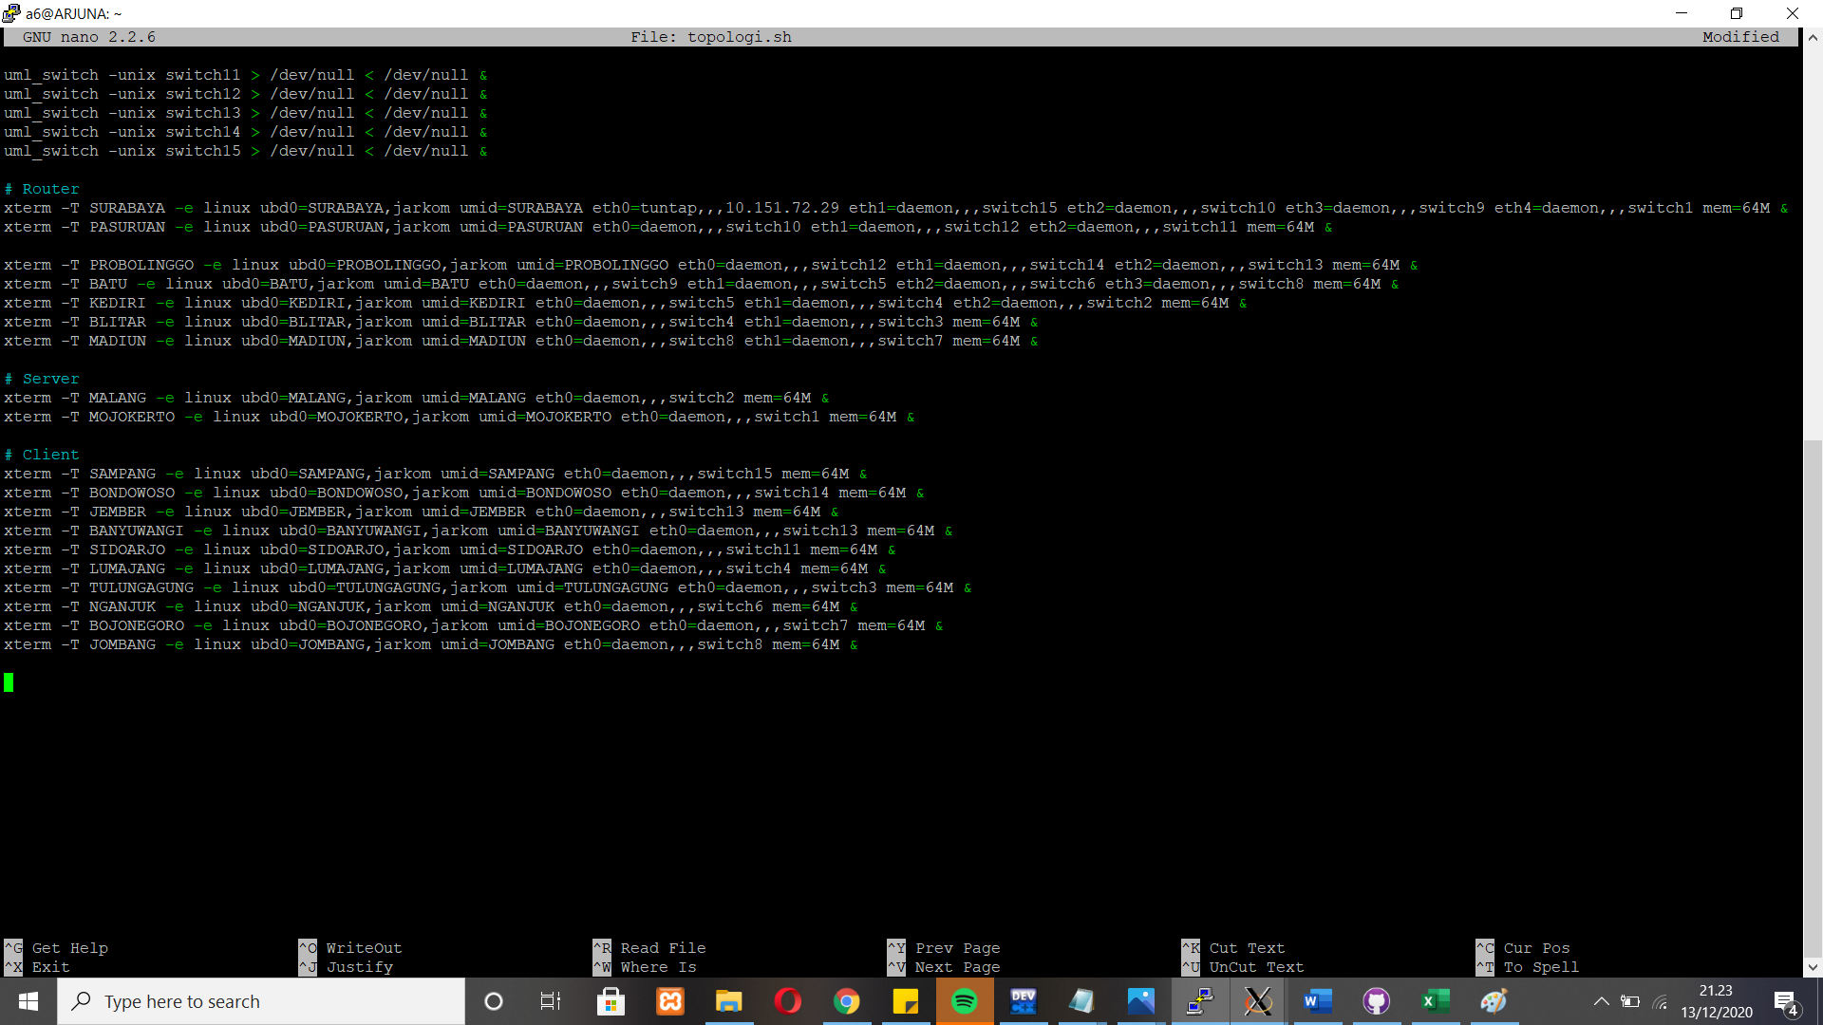

service

* **Pembagian IP**

|  |  |  |  |  |  |  |
| --- | --- | --- | --- | --- | --- | --- |
| SURABAYA | eth0 |  |  | 10.151.72.30 | 255.255.255.0 | 10.151.72.29 |
| eth1 | A1 | SAMPANG | 192.168.64.1 | 255.255.252.0 |  |
| eth2 | A2 | PASURUAN | 192.168.192.1 | 255.255.255.252 |  |
| eth3 | A6 | BATU | 192.168.32.1 | 255.255.255.252 |  |
| eth4 |  | MOJOKERTO | 10.151.73.56 | 255.255.255.252 |  |
| PASURUAN | eth0 | A2 | SURABAYA | 192.168.192.2 | 255.255.255.252 | 192.168.192.1 |
| eth1 | A3 | PROBOLINGGO | 192.168.144.1 | 255.255.255.252 |  |
| eth2 | A7 | SIDOARJO | 192.168.160.1 | 255.255.252.0 |  |
| PROBOLINGGO | eth0 | A3 | PASURUAN | 192.168.144.2 | 255.255.255.252 | 192.168.144.1 |
| eth1 | A4 | BONDOWOSO | 192.168.136.1 | 255.255.255.128 |  |
| eth2 | A8 | BANYUWANGI - JEMBER | 192.168.128.1 | 255.255.248.0 |  |
| BATU | eth0 | A6 | SURABAYA | 192.168.32.2 | 255.255.255.252 | 192.168.32.1 |
| eth1 | A11 | KEDIRI | 192.168.20.1 | 255.255.255.252 |  |
| eth2 | A10 | NGANJUK | 192.168.8.1 | 255.255.252.0 |  |
| eth3 | A5 | JOMBANG | 192.168.0.1 | 255.255.254.0 |  |
| MADIUN | eth0 | A5 | BATU | 192.168.0.2 | 255.255.254.0 | 192.168.0.1 |
| eth1 | A9 | BOJONEGORO | 192.168.4.1 | 255.255.255.240 |  |
| KEDIRI | eth0 | A11 | BATU | 192.168.20.2 | 255.255.255.252 | 192.168.20.1 |
| eth1 | A13 | LUMAJANG | 192.168.18.1 | 255.255.255.0 |  |
| eth2 |  | MALANG | 10.151.73.58 | 255.255.252.0 |  |
| BLITAR | eth0 | A13 | KEDIRI | 192.168.18.2 | 255.255.255.0 | 192.168.18.1 |
| eth1 | A12 | TULUNGAGUNG | 192.168.16.1 | 255.255.252.0 |  |
| SAMPANG | eth0 | A1 | SURABAYA | 192.168.64.2 | 255.255.252.0 | 192.168.64.1 |
| BONDOWOSO | eth0 | A4 | PROBOLINGGO | 192.168.136.2 | 255.255.255.128 | 192.168.136.1 |
| JEMBER | eth0 | A8 | PROBOLINGGO | 192.168.128.2 | 255.255.248.0 | 192.168.128.1 |
| BANYUWANGI | eth0 | A8 | PROBOLINGGO | 192.168.128.3 | 255.255.248.0 | 192.168.128.1 |
| SIDOARJO | eth0 | A7 | PASURUAN | 192.168.160.2 | 255.255.252.0 | 192.168.160.1 |
| JOMBANG | eth0 | A5 | BATU | 192.168.0.3 | 255.255.254.0 | 192.168.0.1 |
| BOJONEGORO | eth0 | A9 | MADIUN | 192.168.4.2 | 255.255.255.240 | 192.168.4.1 |
| NGANJUK | eth0 | A10 | BATU | 192.168.8.2 | 255.255.252.0 | 192.168.8.1 |
| LUMAJANG | eth0 | A13 | KEDIRI | 192.168.18.2 | 255.255.255.0 | 192.168.18.1 |
| TULUNGAGUNG | eth0 | A12 | BLITAR | 192.168.16.2 | 255.255.252.0 | 192.168.16.1 |
| MOJOKERTO | eth0 |  |  | 10.151.73.56 | 255.255.255.252 | 10.151.73.55 |
| MALANG | eth0 |  |  | 10.151.73.58 | 255.255.252.0 | 10.151.73.57 |

* **Interfaces**

